# Introduction to Da Vinci PDex: Plan Net

Da Vinci® PDex Plan Net is an implementation guide based on the Validated Healthcare Directory (VHDir). Plan Net is designed to facilitate the exchange of healthcare directory data by defining a set of constraints and extensions to FHIR® Resources. The extended Resources include, among others, Network, Organization, Practitioner, and Location. The extended data includes many useful directory values, including relationships between and among those Resources. Some relationships between the different Resources that are extended by Plan Net are depicted below.

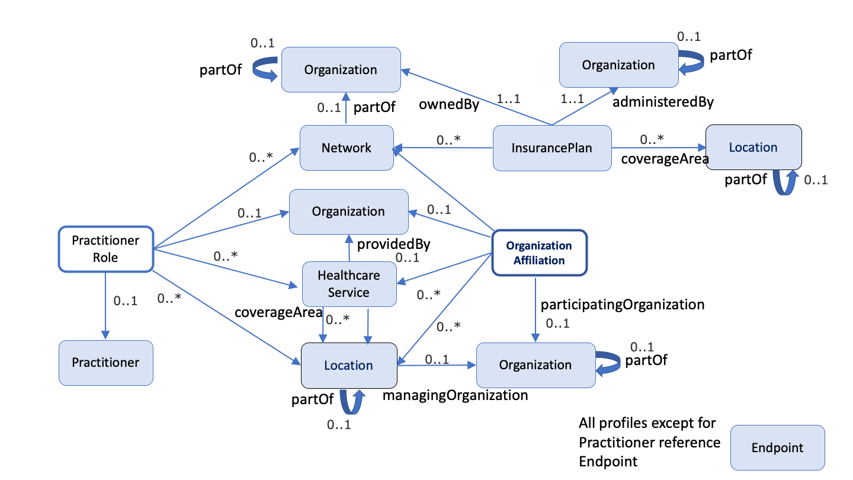

These relationships and data extensions create several possibilities for provider directories. For example, it is now possible to search for a specialist who accepts a patient’s insurance plan and is accepting new patients.

In this TRC, you will explore several scenarios related to provider directories, and walk through the requests necessary to find information for several different use cases.

***Note:*** *Throughout this document, example queries will be provided. Queries can be sent via an API client or modified to better suit your needs.*

Contents

Introduction to Da Vinci PDex: Plan Net 1

Scenario 1: Searching with Da Vinci PDex Plan Net 4

Problem Statement 4

Problem Solution 4

Stakeholder Participation 4

Query 1, Method A: Find a Practitioner id by Name Using the IOL Interface 4

Query 1, Method B: Finding a Practioner by id by Name Using an API Client 6

Scenario 2: Searching for Specialists Within a City 10

Sample User Story 10

Problem Statement 10

Problem Solution 10

Stakeholder Participation 10

Query 1: Find Relevant Practice Codes 11

Query 2: Search for locations in a patient’s city 12

Query 3: Find a specialist at our location 13

Scenario 3: Finding a Patient/Provider Care History 15

Sample User Story 15

Problem Statement 15

Stakeholder Participation 15

Query 1: Find a Patient id and the Associated Practitioner id 15

Query 2: Find the Patient/ Provider Care History 17

Scenario 4: Find All Coverage Resources for a Patient 18

Sample User Story 18

Problem Statement 18

Stakeholder Participation 18

Query 1: Find the Patient Coverage by Patient id 19

Scenario 5: Find the Healthcare Services Available at a Given Hospital or Clinic 21

Sample User Story 21

Problem Statement 21

Stakeholder Participation 21

Query 1: Find the Location id 21

Query 2: Find Available Services at a Location 23

Scenario 6: Find a Practitioner’s Office Address 25

Sample User Story 25

Problem Statement 25

Stakeholder Participation 25

Query 1: Find the Location id Using the PractitionerRole record 25

Query 2: Find the Location 27

# Scenario 1: Searching with Da Vinci PDex Plan Net

## Problem Statement

Jennifer lives in Mason, Michigan. She has just received a recommendation from a friend about an excellent primary care physician in her area. Jennifer would like to schedule an appointment with this doctor, but cannot recall anything other than the doctor’s name, Katherine Taylor.

How can she find more information about the doctor her friend described to her?

## Problem Solution

**Action:** Explore ways to showcase how to find a Practitioner id by using the patient’s location and provider role data.

**Precondition:** Use the queries listed below in the MiHIN PIT to locate a doctor by name who practices nearby.

**Success Criteria:** Successfully locate a Practitioner id by name using the IOL interface and by using an API client.

## Stakeholder Participation

Queries you will complete:

1. Find an individual practitioner’s id by name using IOL Interface.
2. Find an individual practitioner’s id by name using an API client.

### Query 1, Method A: Find a Practitioner id by Name Using the IOL Interface

In this query you will use the **MiHIN PIT** to find a Practitioner id by name when you directly query the Resource in an API client of your choice. They can be sent via API client or modified to better suit your needs.

1. 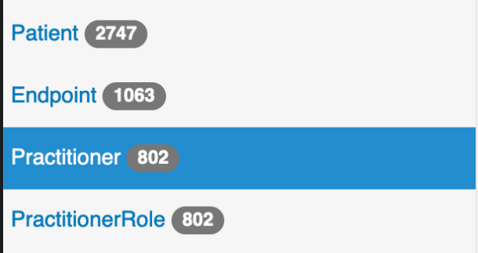Choose your **Practitioner** Resource from within the HIN PIT.
2. Using your **Search** tab, **Search** **Parameters** arrow, choose **name – A server defined search that may match any of...** Then using the **Matches** search tool type the last name of the physician e.g., **Taylor**.
3. Click **Search** ().

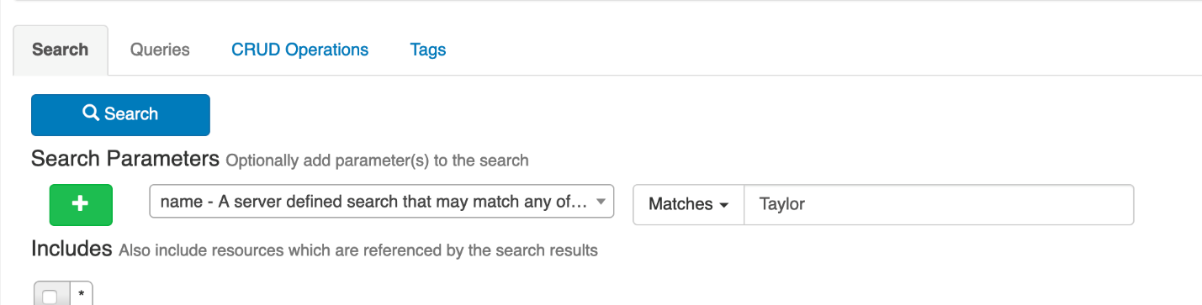

1. The **Result Body** displays your results choosing **Read** the record itself will display and as shown below the first record appears to be a match.

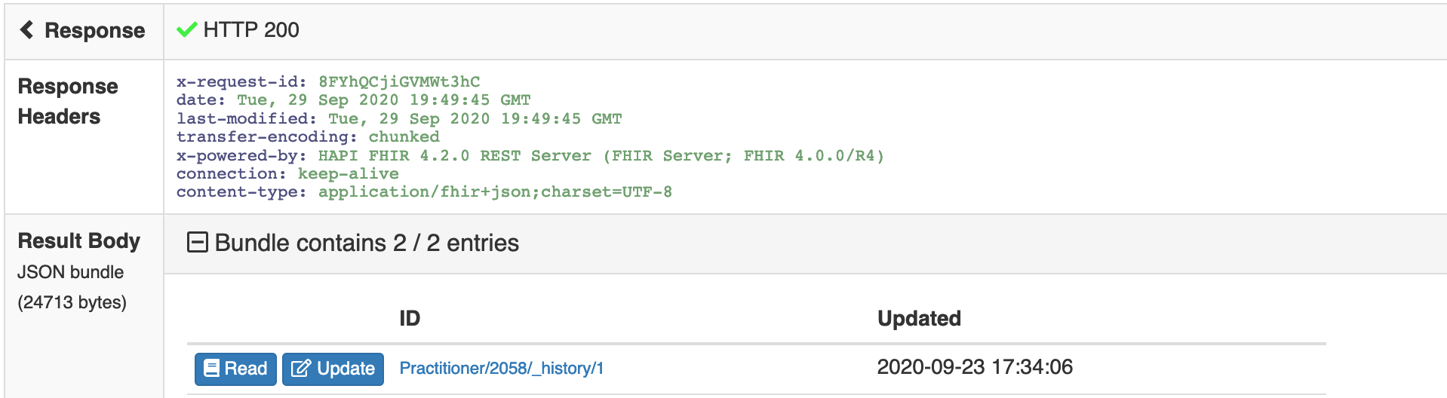

The Raw Message shown below contains the Practitioner’s id.

### Query 1, Method B: Finding a Practioner by id by Name Using an API Client

You can also find a Practitioner id by name by directly querying the Resource using an API client of your choice.

1. Log into IOL and navigate to the relevant Sandbox. Choose the **MiHIN PIT** from the dashboard, and the **Overview** tab will display.

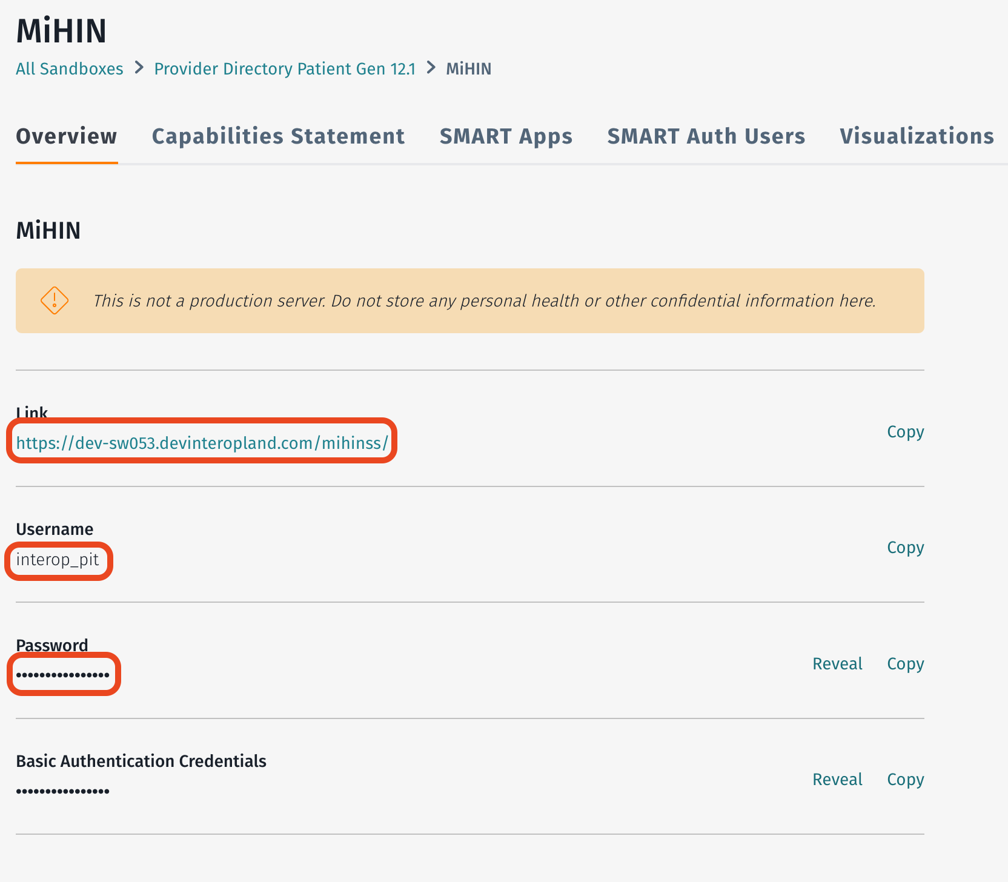***Note:*** *Make a note of the name and URL of the Sandbox as you will need this information in later steps.*

1. Now you can create a query on the **Practitioner** Resource for your directory PIT using the **Postman** tool.
2. Use your **Type** arrow to choose **Basic** **Auth** in the **Auth** tab.
3. Copy the basic auth **Username** and **Password** from the dashboard into the corresponding boxes as shown below.

***Note:*** *The single search parameter is the last name of the doctor, and you will set the Basic Auth credentials to those we collected in the previous step.*

***Tip:*** *Make a note of this information as you will need these credentials for all subsequent API requests*.

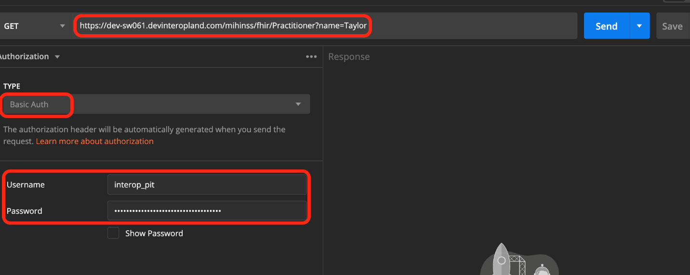

1. Click **Send** and you should see a set of data representing every doctor with the name **Taylor**. As mentioned above, the first record is a match for the practitioner you are looking for, Katherine Taylor.

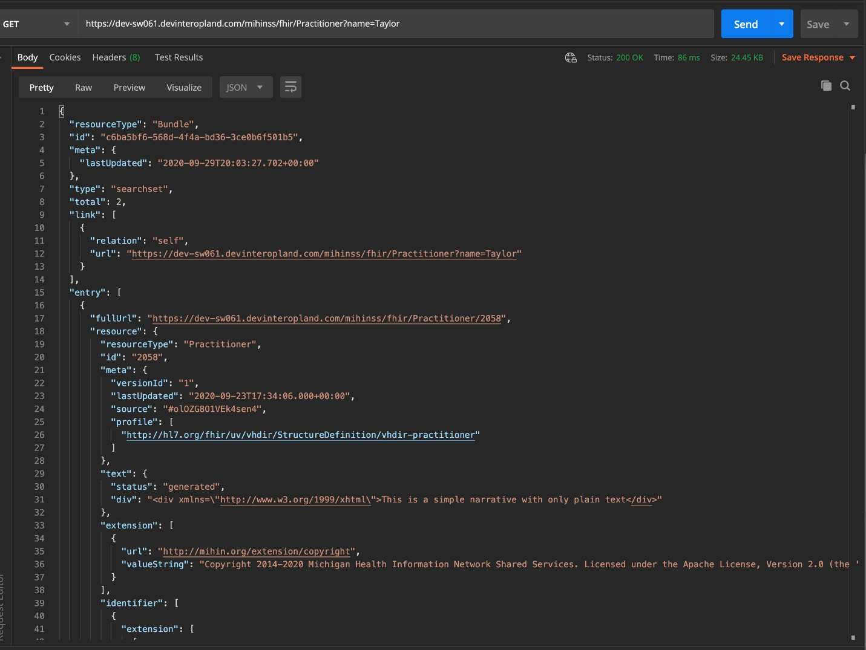

# Scenario 2: Searching for Specialists Within a City

## Sample User Story

Rebecca lives in Onaway, Michigan. Her health is generally exceptional, but lately she’s been having trouble with an old skiing injury that resulted in a broken foot. Her foot didn’t quite heal correctly, and now she’s experiencing significant pain when she puts any weight on it. She believes she should see a specialist to determine whether she needs surgery to fix the problem. How can she find a foot and ankle specialist in her area?

## Problem Statement

The patient needs to see a foot and ankle specialist who takes her insurance plan, practices nearby, and is accepting new patients.

## Problem Solution

Multiple queries will be used together to create the solution. You will leverage the patient location and provider role data.

## Stakeholder Participation

Queries you will complete:

1. Find the relevant practice code for the specialty.
2. Search for locations in our patient’s city.
3. Find a practitioner at that location that matches the qualification code.

### Query 1: Find Relevant Practice Codes

In this query, you will use the **MiHIN PIT** to do the following tasks:

1. Find the code of the specialty that is best suited to the needs of your patient by referring to the list of **provider taxonomy****codes** as published by the National Uniform Claim Committee (NUCC).
2. To display the full list of taxonomy codes, navigate to the NUCC site, choose **Code** **Sets**, **Provider** **Taxonomy**, **Code** **Lookups**, and then click the **taxonomy.nucc.org** link to be redirected to the **Health Care Provider Taxonomy Code Set**.

***Tip:*** *If you need to download the entire list in CSV format click the following link:*

[*https://www.nucc.org/index.php/code-sets-mainmenu-41/provider-taxonomy-mainmenu-40/csv-mainmenu-57*](https://www.nucc.org/index.php/code-sets-mainmenu-41/provider-taxonomy-mainmenu-40/csv-mainmenu-57)

The example below demonstrates two ways to find your Taxonomy code. When you are redirected to the taxonomy.nucc.org code set page, you can scroll through the list on the left to find a provider specialty name such as **Foot and Ankle** or if known, type the specialty code i.e., **207XX0004X** in the **Search** box and click **Search**.

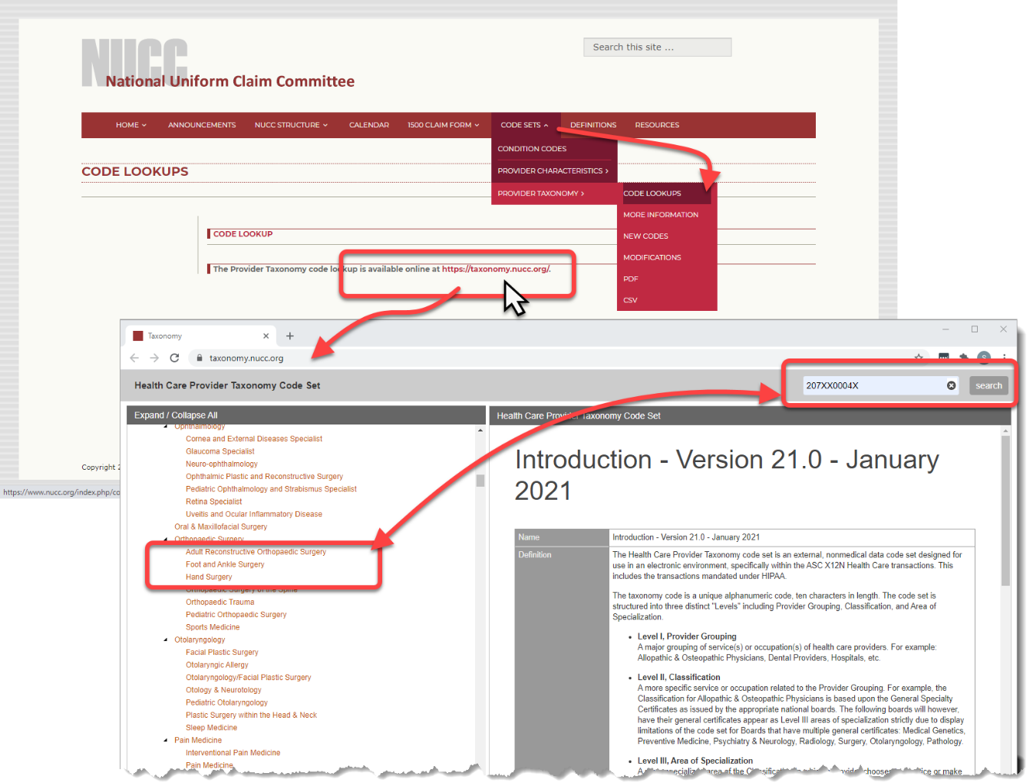

### Query 2: Search for locations in a patient’s city

In this query you will use the **MiHIN PIT** eRequests on your Payer PIT to:

1. Choose your **Location** Resource. Now you will set up a query using two search parameters.
2. Using your **Search Parameters** arrow, choose **address-state – A state specified in an address** and with the corresponding search box set to **Matches**, type **MI**.
3. Click the **Add** tool () and choose **address-city – A city specified in an address** and with the corresponding search box set to **Matches**, type **Onaway**.
4. Click **Search** ().

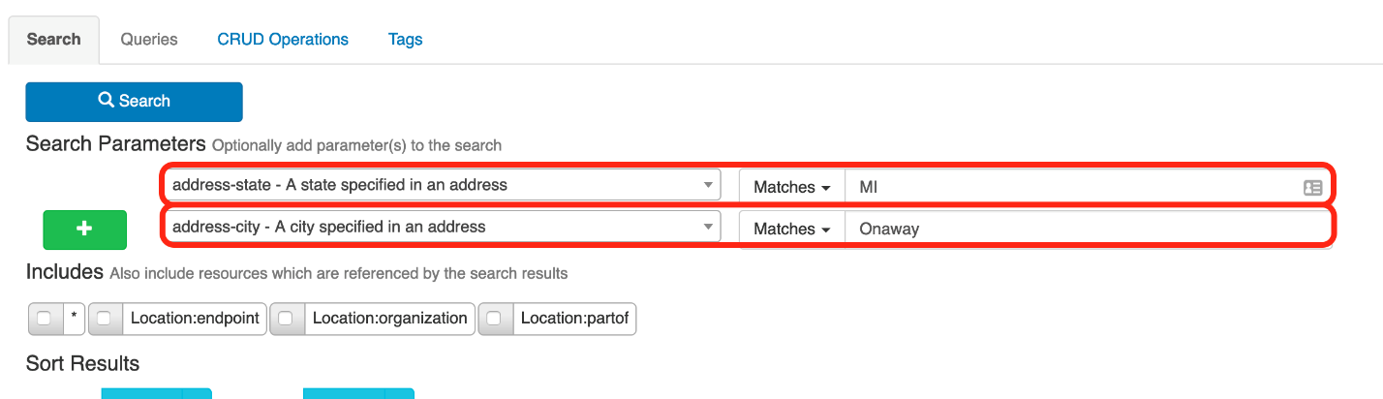

1. Several records match representing the departments of Ruth Israel Hospital. Click **Read** to view the first record as it may be a suitable candidate for your needs. Make a note of the **id** (**364**) for use in another query.

***Tip:*** *If you choose, you can use the following GET Request:*

*GET* [*https://dev-sw081.devinteropland.com/mihinss/fhir/Location?address-city=Onaway&address-state=MI*](https://dev-sw081.devinteropland.com/mihinss/fhir/Location?address-city=Onaway&address-state=MI&_pretty=true)

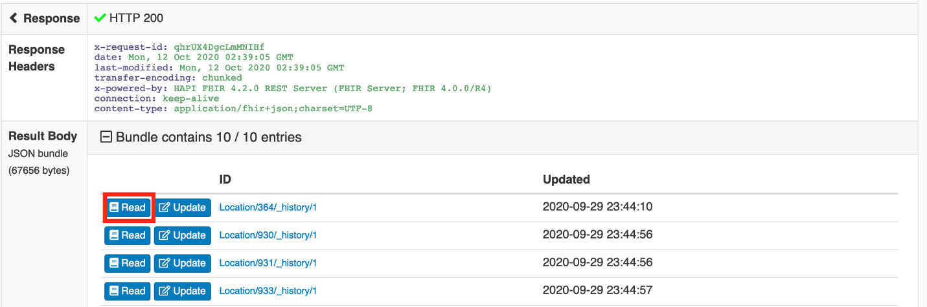

### Query 3: Find a specialist at our location

In this query you will use the **MiHIN PIT** to:

1. 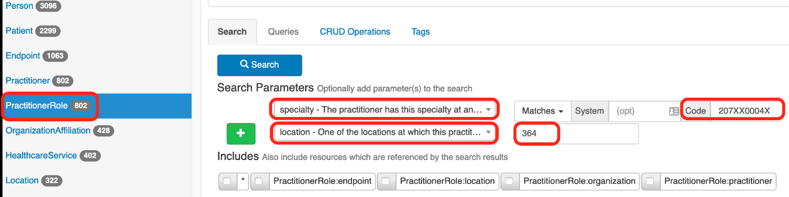Once you have the code for the specialist you are looking for and the location you wish to search, you can identify any practitioners at Ruth Israel Hospital who specialize in foot and ankle surgery. Click your **PractitionerRole** Resource and using the **Search** **Parameters** arrow, choose **specialty – The practitioner has this specialty at an…,** verify **Matches** displays **System (opt)**, and then use your **Code** box to type the code you used previously i.e., **207XX0004X***.*

1. Click the **Add** tool () to choose a second parameter and select **location – One of the locations at which this practice…,** use the corresponding search box to type the location **id** you acquired previously.
2. Click **Search** ().



1. The results indicate that there is one specialist at Williams Orthopedic clinic that specializes in Foot and Ankle Surgery. Click **Read** or scroll down to see the full record including name, licensing information, and whether the practitioner is currently accepting new patients.

***Tip:*** *If you choose, you can use the following GET Request:*

*GET* [*https://dev-sw081.devinteropland.com/mihinss/fhir/PractitionerRole?specialty=207XX0004X&location=364*](https://dev-sw081.devinteropland.com/mihinss/fhir/PractitionerRole?specialty=207XX0004X&location=364&_pretty=true)

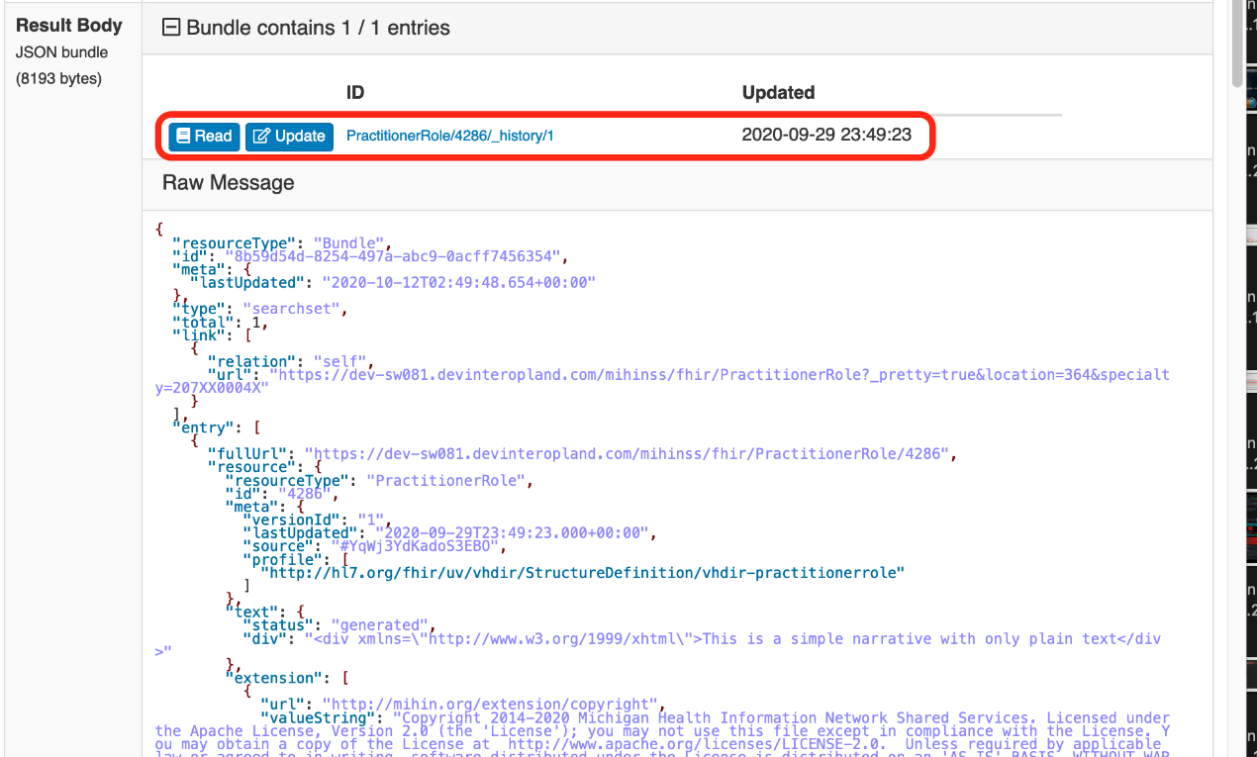

# Scenario 3: Finding a Patient/Provider Care History

## Sample User Story

Dr. Leslie Whedon is filling in for an associate of hers, Dr. Carmen Douglas, at the Global Southside Urgent Care Center in Freeland, MI. She is scheduled to meet with a patient named Erin Walsh and would like to review Erin’s care history with Dr. Douglas prior to the appointment. How can we locate the complete care history between Dr. Douglas and Erin?

## Problem Statement

Practitioner A needs to find the complete care history between a patient and Practitioner B.

## Stakeholder Participation

Queries you will complete:

1. Find the patient id.
2. Find the associated practitioner id.
3. Find previous appointments containing both ids.

### Query 1: Find a Patient id and the Associated Practitioner id

Use the **Blaze Global Health PIT** to find this solution.

1. Begin by locating the ID of the patient in our database. In this example, Dr. Whedon has access to Erin’s Social Security Number e.g., 000004599. Click **Patient** Resource and use the Search Parameters arrow to choose your**identifier – A patient identifier** parameter, verify **Matches** displays **System (opt)**, and then type Erin’s Social Security number in the **Code** search box.
2. Click **Search** ().

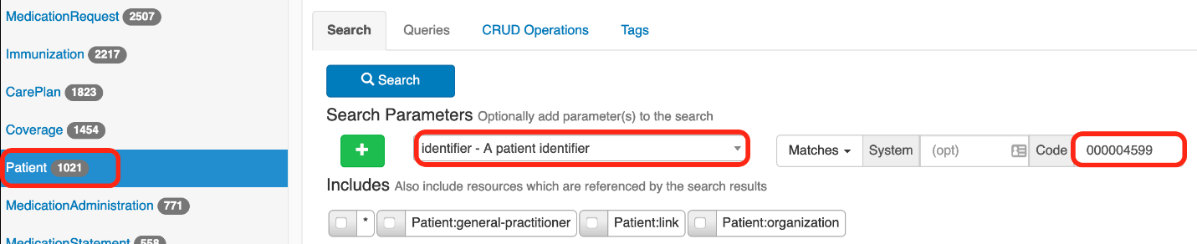

***Tip:*** *If you choose, you can use the following GET Request:*

*GET [https://dev-sw081.devinteropland.com/blaze-global-health-system/fhir/Patient?identifier=000004599](https://dev-sw081.devinteropland.com/blaze-global-health-system/fhir/Patient?identifier=000004599&_pretty=true)*

1. There is one matching record. Click **Read** or scroll down to view the record in full.

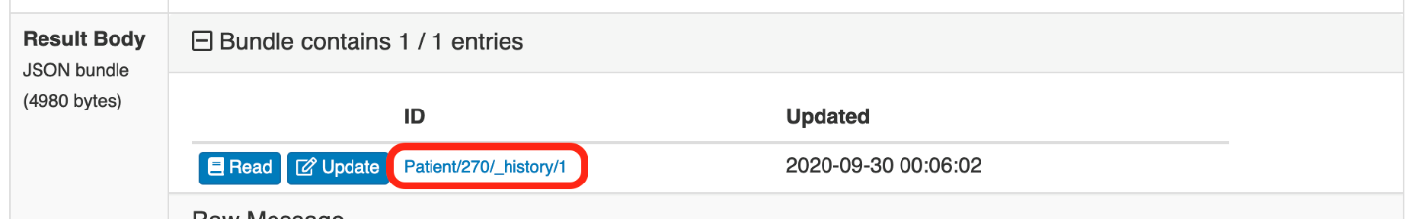

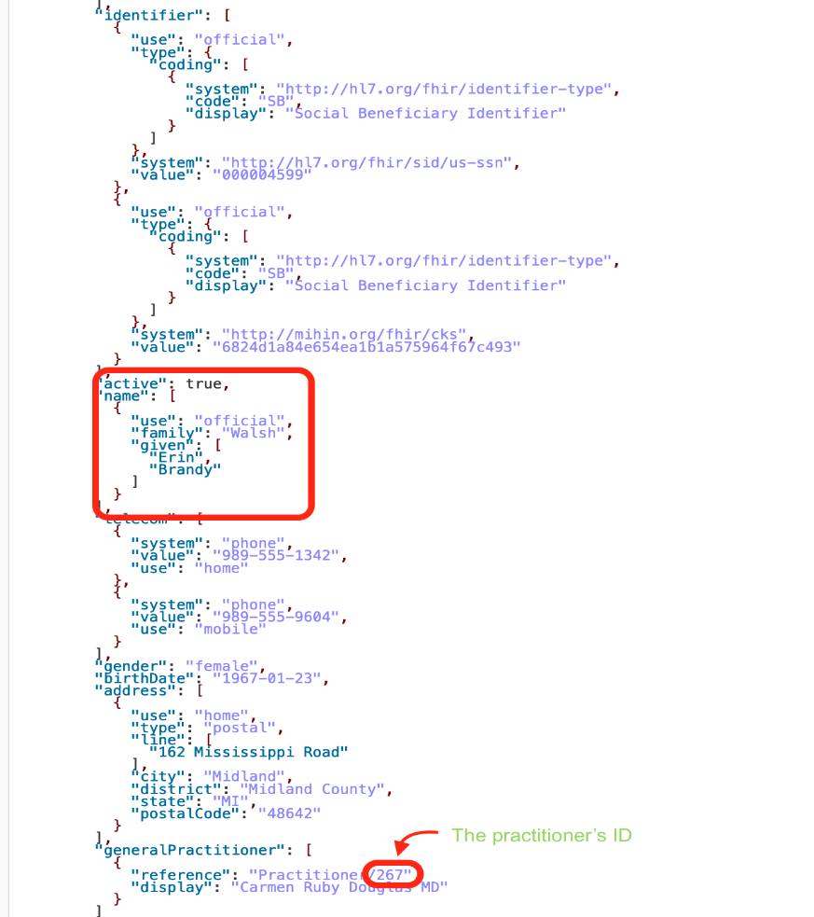The record matches patient Erin, and you can see Dr. Douglas listed as her general practitioner.

Make a note of both her **ID** (**270**) and that of **Dr.** **Douglas** (**267**).

### Query 2: Find the Patient/ Provider Care History

1. Using the Location id for both the patient and her doctor, you can see all previous appointments the two have had together. Choose the **Encounter** Resource using your **Search** **Parameter** arrow choose **patient – The patient or group present at the encounter…** and then using the patient id search box type Erin’s patient id.
2. Click the **Add** tool () to choose a second parameter and select **practitioner – Persons involved in the encounter…** use the corresponding search box to type the **practitioner id** you acquired previously.
3. Click **Search** ().

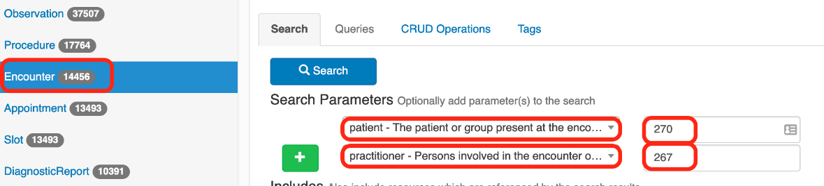

1. The results indicate three prior appointments between Erin and Dr. Douglas. Click your **Read** button or scroll down to see full details about each of the appointments.

***Tip:*** *If you choose, you can use the following GET Request:*

*GET [https://dev-sw081.devinteropland.com/blaze-global-health-system/fhir/Encounter?patient=270&practitioner=267](https://dev-sw081.devinteropland.com/blaze-global-health-system/fhir/Encounter?patient=270&practitioner=267&_pretty=true)*

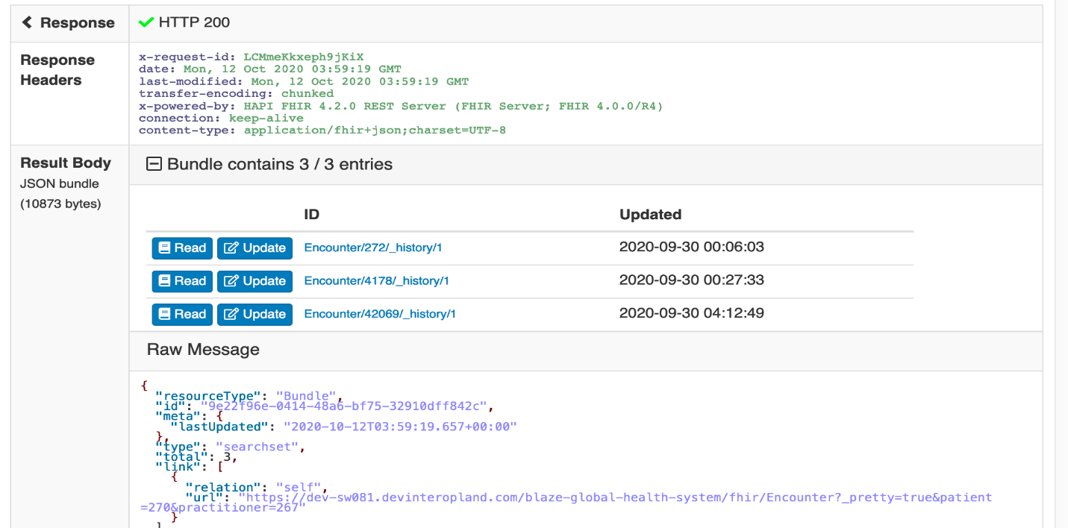

# Scenario 4: Find All Coverage Resources for a Patient

## Sample User Story

Erin Walsh is a new patient of Dr. Douglas, who belongs to a large network. How can Erin find out what her coverage is?

## Problem Statement

Find all instances of coverage Resources for a specific patient.

## Stakeholder Participation

Queries you will complete:

1. Find the patient id.
2. Find all coverage types associated with the patient.

### Query 1: Find the Patient Coverage by Patient id

Use the **Blaze Global Health PIT** and Erin Walsh’s Patient id (270) to find this solution.

1. Choose the **Coverage** Resource, and then using the **Search** **Parameter** arrow choose **patient – Retrieve coverages for a patient...**  Using the search box, type Erin’s **Patient id** (**270**).
2. Click **Search** ().

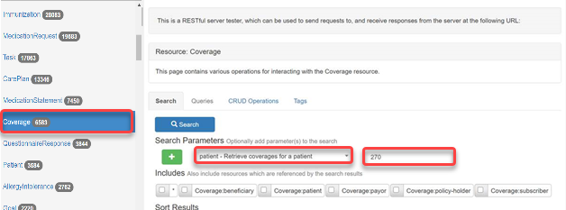

1. Two **Resources** will display showing coverage for the patient and then click your Read button or scroll down to see full details about each of the coverage.

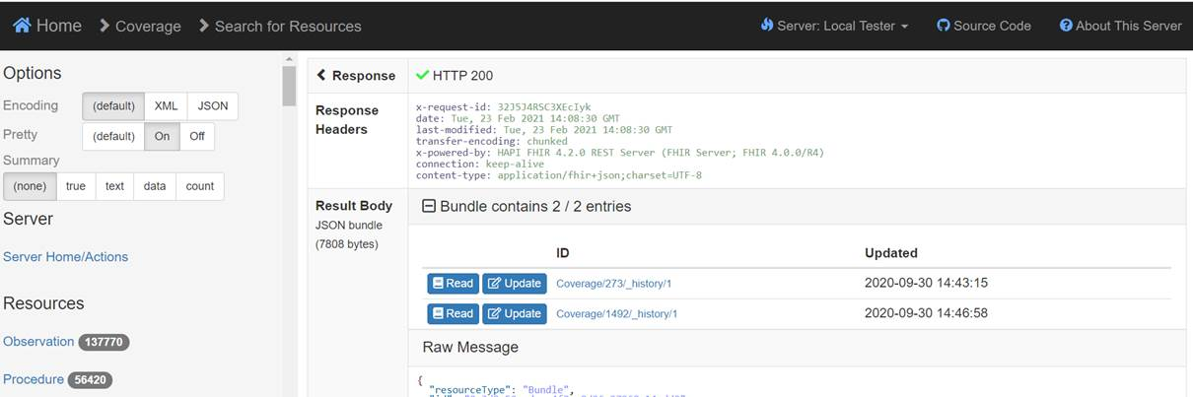

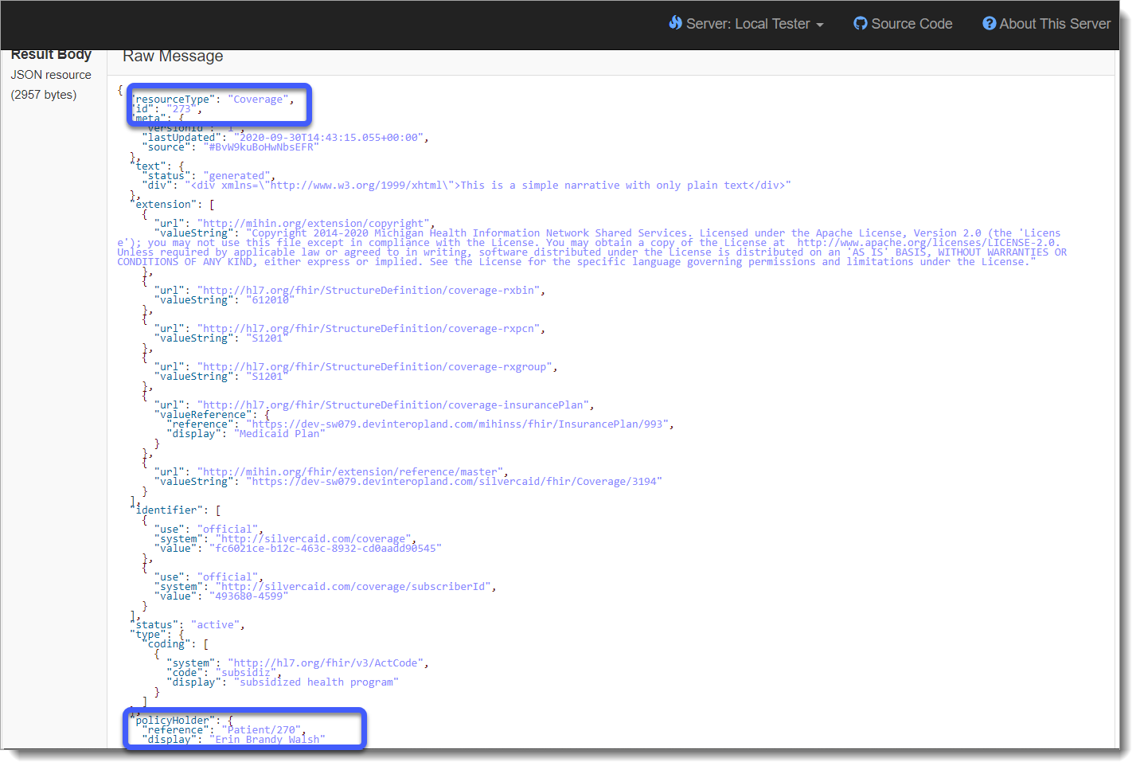The results indicate that the Coverage Resource ID, coverage number, and patient name will display in your Raw Message.

# Scenario 5: Find the Healthcare Services Available at a Given Hospital or Clinic

## Sample User Story

Anita Johnson is pregnant with her second child and needs to designate a hospital on her birth plan. She gave birth to her first baby at St. Mary’s hospital, which has since closed. The premier delivery center is at Windward Hospital. How can she find out what services they offer?

## Problem Statement

Use a hospital or clinic name to discover the services at a specific location.

## Stakeholder Participation

Queries you will complete:

1. Use a hospital or clinic name to find the Location id.
2. Discover services provided at a location.

### Query 1: Find the Location id

Use the **MiHIN PIT** to find the solution.

1. Begin with finding the hospital Location id by navigating to and choosing your **Location** Resource. In this example, you will search for Windward General Hospital. Using the **Search Parameter** arrow, choose **name – A portion of the location’s name or alias,** verify **Matches** is chosen, and then type **Windward General Hospital.**
2. Click **Search** ().

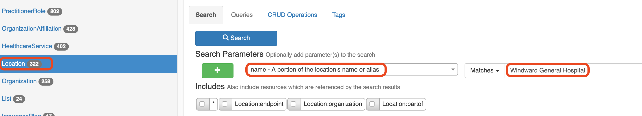

1. Nine matching entries display. The first is **Windward General Hospital**, and the rest are its child facilities.

Make a note of the of your **Hospital id** as you will need it later.

***Tip:*** *If you choose, you can use the following GET Request:*

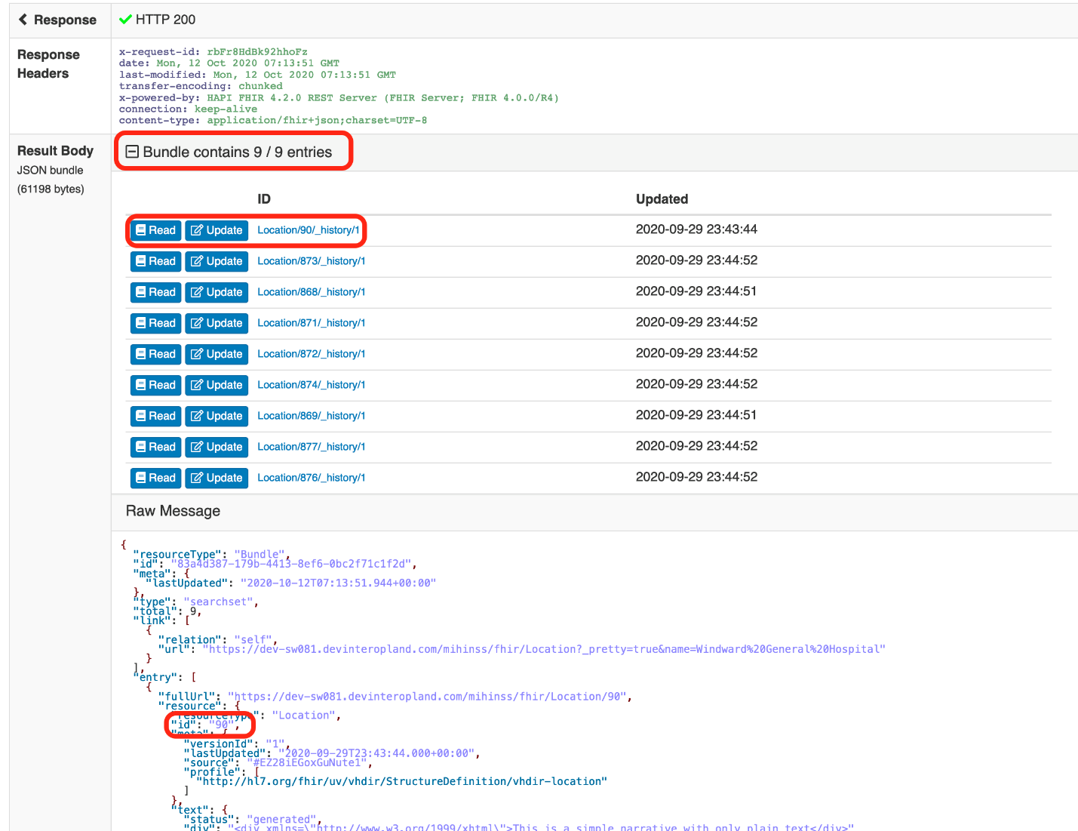*GET [https://dev-sw081.devinteropland.com/mihinss/fhir/Location?name=Windward General Hospital](https://dev-sw081.devinteropland.com/mihinss/fhir/Location?name=Windward%20General%20Hospital&_pretty=true)*

### Query 2: Find Available Services at a Location

Use the **MiHIN PIT** and the **Hospital id (90)** to find the solution.

1. Once you have the id of your hospital location, you can choose the **HealthcareService** Resource to discover which services are provided at that location. Using your Search Parameters arrow, choose **location – The location of the Healthcare Service**, type your **Hospital id** (**90**) in the corresponding search box.
2. Click **Search** ().

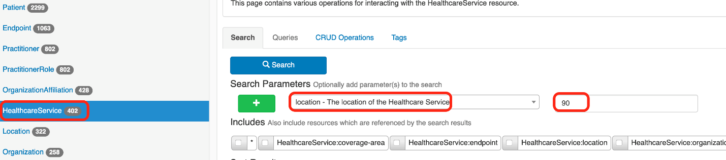

***Tip:*** *If you choose, you can use the following GET Request:*

*GET [https://dev-sw081.devinteropland.com/mihinss/fhir/HealthcareService?location=90](https://dev-sw081.devinteropland.com/mihinss/fhir/HealthcareService?location=90&_pretty=true)*

1. Eight HealthcareService Resources are found. Click **Read** to see information contained in the Resource.

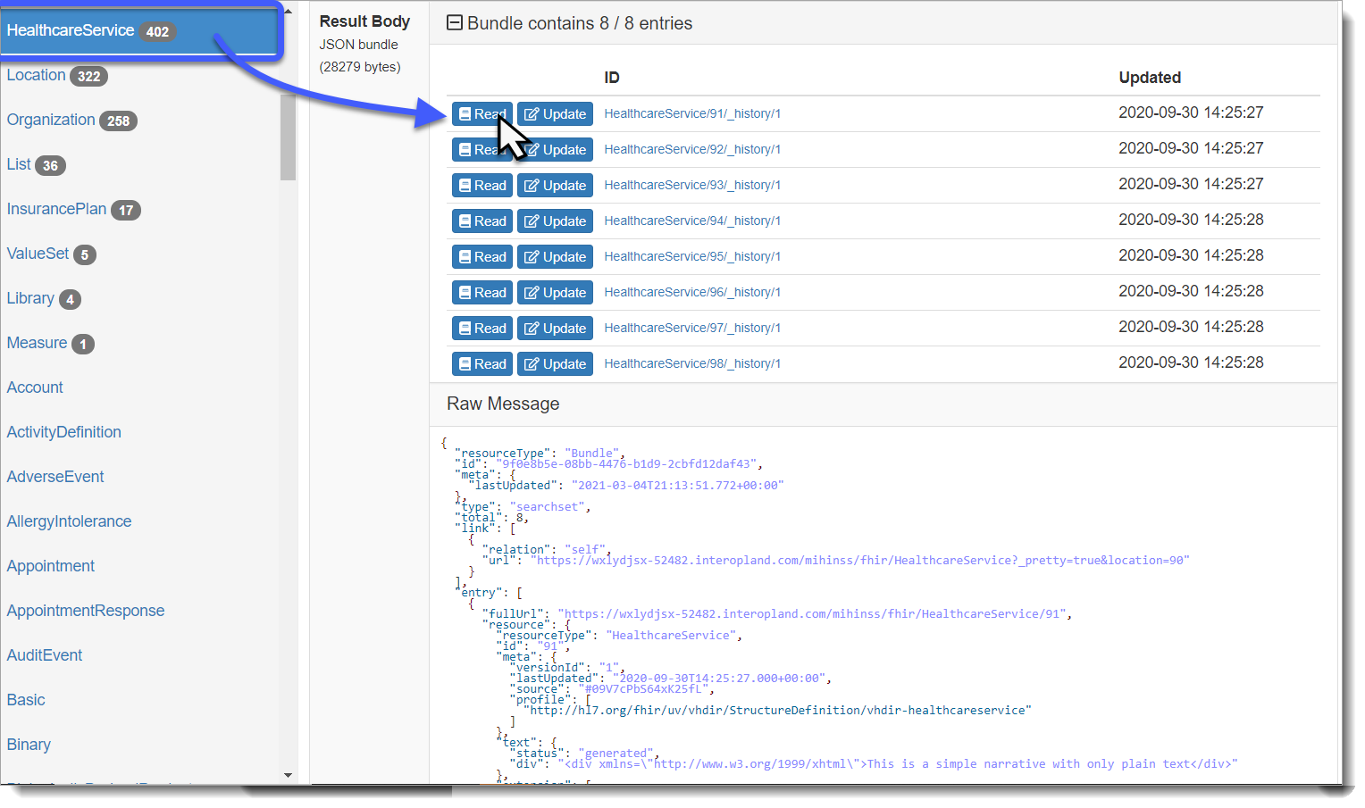Each will show a different service that the location provides.

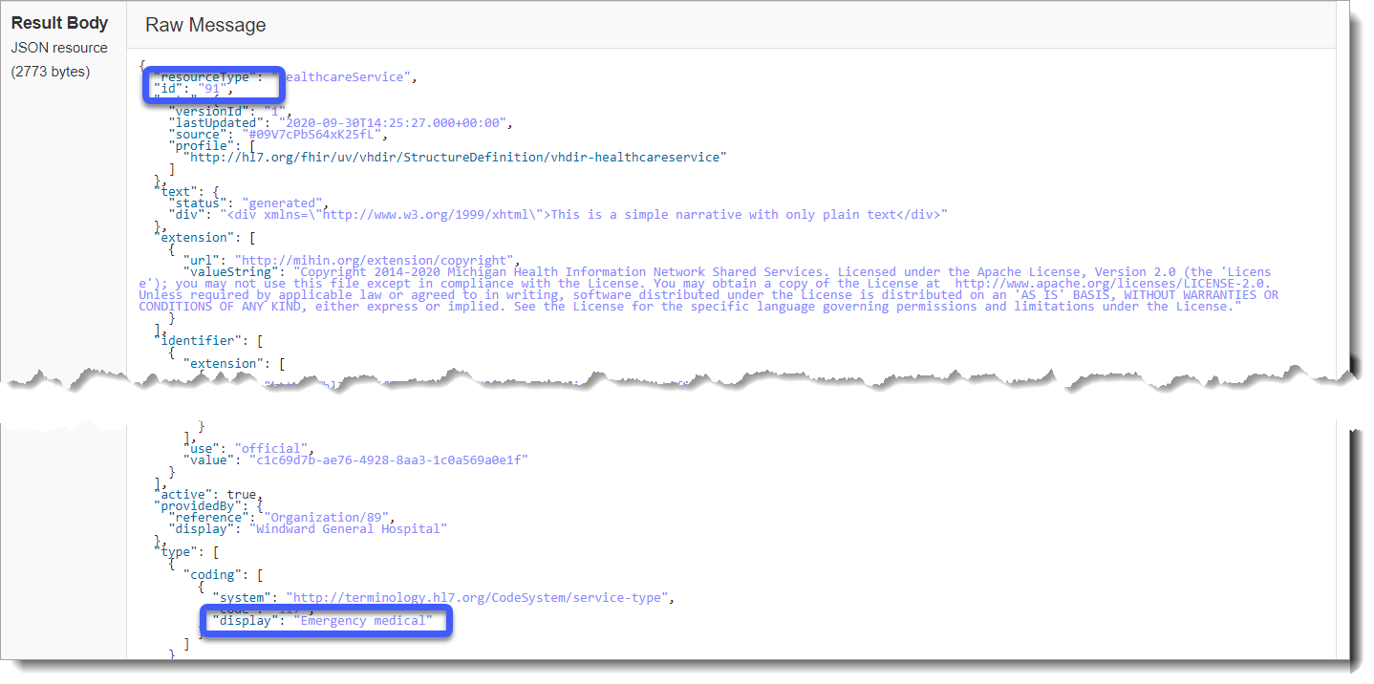

# Scenario 6: Find a Practitioner’s Office Address

## Sample User Story

Tom Johnson wants to see Dr. Marian McCall, an ear nose and throat specialist. He hasn’t seen her in several years and has heard that she no longer works at the office closest to him. How does he find out where she keeps evening office hours now?

## Problem Statement

There is a work address in the Practitioner record for Dr. McCall, but the Practitioner record may not be updated or might be missing entirely. A better source for an office address may be a PractitionerRole record for our practitioner, which is associated with a Location.

## Stakeholder Participation

Queries you will complete:

1. Find the location id using the PractitionerRole Resource.
2. Find the address using the Location Resource.

### Query 1: Find the Location id Using the PractitionerRole record

Use the **MiHIN PIT** and the **Practitioner id (2059)** to find a solution.

1. Navigate to your **PractitionerRole**Resource. Using your **Search Parameters** arrow, choose **practitioner – Practitioner that is able to provide the defined services to…** and then type your **Practitioner id** (**2059**) in the corresponding search box.
2. Click **Search** ().

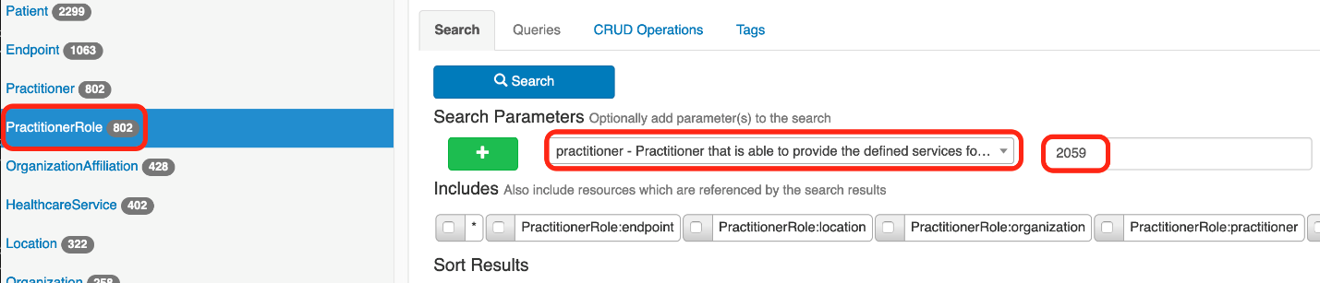

1. The **Result Body** indicates one **PractitionerRole** entry match as a result of your search. Click **Read**or scroll down to find the**location reference** (**Location/644**).

Make a note of the **Location id** as you will need it later.

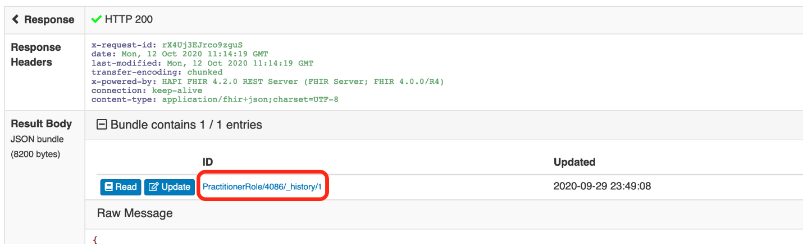

***Tip:*** *If you choose, you can use the following GET Request:*

*GET* [*https://dev-sw081.devinteropland.com/mihinss/fhir/PractitionerRole?practitioner=2059*](https://dev-sw081.devinteropland.com/mihinss/fhir/PractitionerRole?practitioner=2059&_pretty=true)

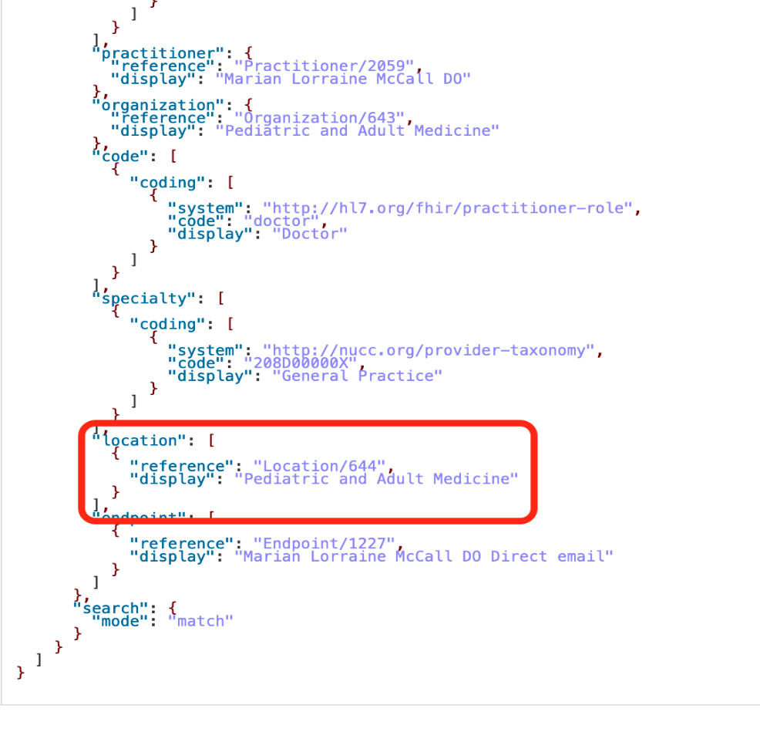

### Query 2: Find the Location

Use the **MiHIN PIT** and the **Location id (2059)** to find the solution.

1. Navigate to your **Location**Resource. Using your **Search Parameters** arrow, choose **_id – The ID of the resource**, verify **Matches** displaysas **System, (opt),** and then using the **Code** search box, type the **Location** **id** you found in the previous query.
2. Click **Search** ().

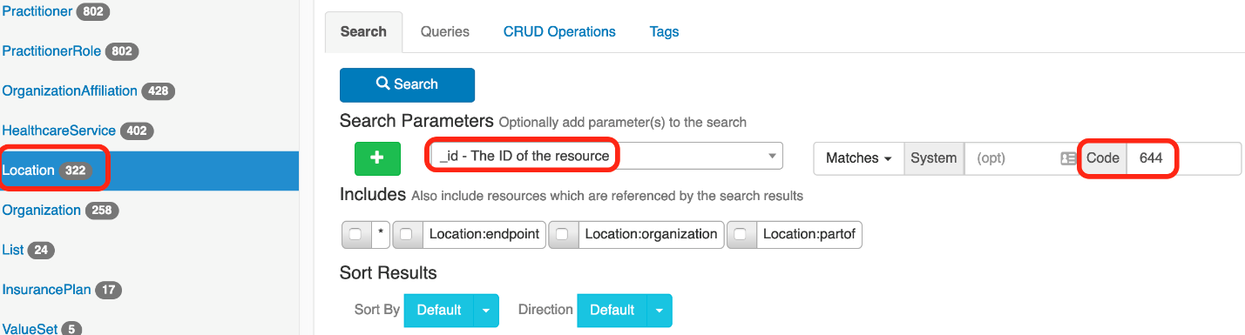

1. Scroll down the Raw Message to the **use**, **type** **physical** to find Dr. McCall’s work address.

***Tip:*** *If you choose, you can use the following GET Request:*

*GET* [*https://dev-sw081.devinteropland.com/mihinss/fhir/Location?_id=644*](https://dev-sw081.devinteropland.com/mihinss/fhir/Location?_id=644&_pretty=true)

